**Participant Consent Form**

**Empowering Education: Revolutionizing Learning with an Anti-Cheating Quiz Mastery System**

**Consent to Take Part in Research**

* I, ___Jenny Wenceslao____ voluntarily agree to participate in this research study.

* I understand that even if I agree to participate now, I can withdraw at any time or refuse to answer any question without any consequences of any kind.

* I understand that I can withdraw permission to use data from my interview within two weeks after the interview, in which case the material will be deleted.

* I have had the purpose and nature of the study explained to me in writing and I have had the opportunity to ask questions about the study.
* I understand that participation involves answering questions in a survey that is related to online cheating examinations.

* I understand that I will not benefit directly from participating in this research.

* I agree that my responses in a survey will be collected.

* I understand that all information I provide for this study will be treated confidentially.

* I understand that in any report on the results of this research my identity will remain anonymous. This will be done by changing my name and disguising any details of my interview which may reveal my identity or the identity of people I speak about.
* I understand that if I inform the researcher that I or someone else is at risk of harm they may have to report this to the relevant authorities - they will discuss this with me first but may be required to report with or without my permission.

* I understand that signed consent forms and my responses to a survey questionnaire will be retained securely in IT Department, accessible only to authorized personnel.

* I understand that under freedom of information legalization I am entitled to access the information I have provided at any time while it is in storage as specified above.

* 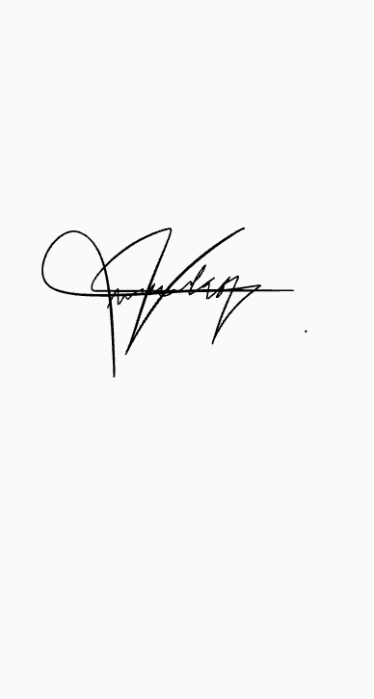I understand that I am free to contact any of the people involved in the research to seek further clarification and information.

05-16-24

JENNY WENCESLAO

__________________________________________ --------------

(Signature of Research Participant over Printed Name) Date Signed

If necessary, you may contact us:

**ANTON NEIL Y. ANDALES**

**MRS. EMILY L. ONG**

UVCS, CETA

Course Instructor

Contact No. 09950315801

Primary Researcher

Email: eong@uv.edu.ph

Email: antonneil_andales@uv.edu.ph

**MR. ALAN A. FELICANO**

Program Coordinator

UVCS, CETA

Email: afelicano@uv.edu.ph

**RHEA MAE D. BORROMEO**

Secondary Researcher

Contact No. 09276155374

Email: rheamae_borromeo@uv.edu.ph

I believe the participant is giving informed consent to participate in this study.

**ANTON NEIL Y. ANDALES ----------------** (Signature of Researcher over Printed Name) Date Signed